**PROJECT TITLE: TASK HUB APP**

**INTRODUCTION**

Keeping track of tasks can be tough, especially with busy schedules. That's why we set out to create a simple, yet powerful task management app. Our goal was to make it easy for anyone to stay organized and get things done. Our app has different features to help you stay organized and get things done.

We made sure to include all the important stuff first. You can create tasks, mark them as done, and set reminders to stay on track. Then, we added some extra helpful features. You can break tasks into smaller parts, keep track of your progress, and set timelines to reach your goals.

**TEAM MEMBERS**

|  |  |
| --- | --- |
| **MEMBER** | **STUDENT NUMBER** |
| NASAAZI TAKIA | 2200706674 |
| KAZIBWE JULIUS | 2100714318 |
| KISA JEREMIAH | 1700714396 |

**Github :**

**https://github.com/julius-kazibwe/Mobile_Programming_Project.git**

**IMPLEMENTED FEATURES**

**Login:** The Login feature lets users log in using their Google account. We used Firebase Authentication to do this. When users open the app, they see the login screen. They can choose to log in with Google. Then, they go to Google's sign-in page. They pick their Google account and give permission for the app to see their basic info, like their profile picture. After that, their Google profile picture shows up in the app. It makes the app feel more personal and friendly.

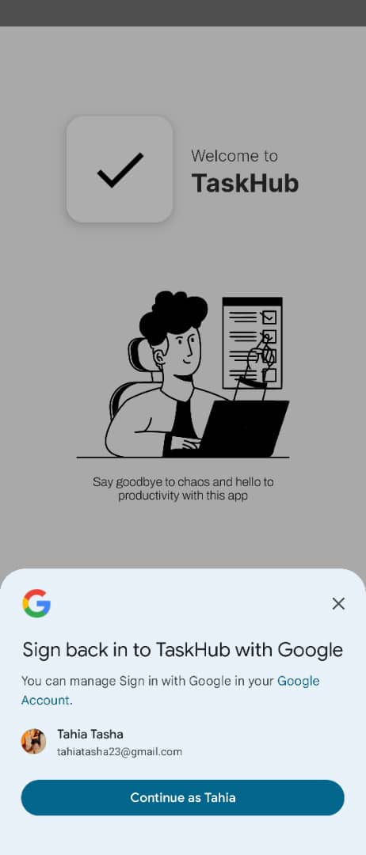

**Task creation:** Our app also includes task creation functionality, allowing users to easily create tasks. Users can initiate task creation by clicking the "Add" button within the app. Once clicked, they are prompted to input essential details such as the task title, due date, and task description. This process empowers users to quickly outline their tasks and set deadlines, ensuring clarity and organization in managing their responsibilities.

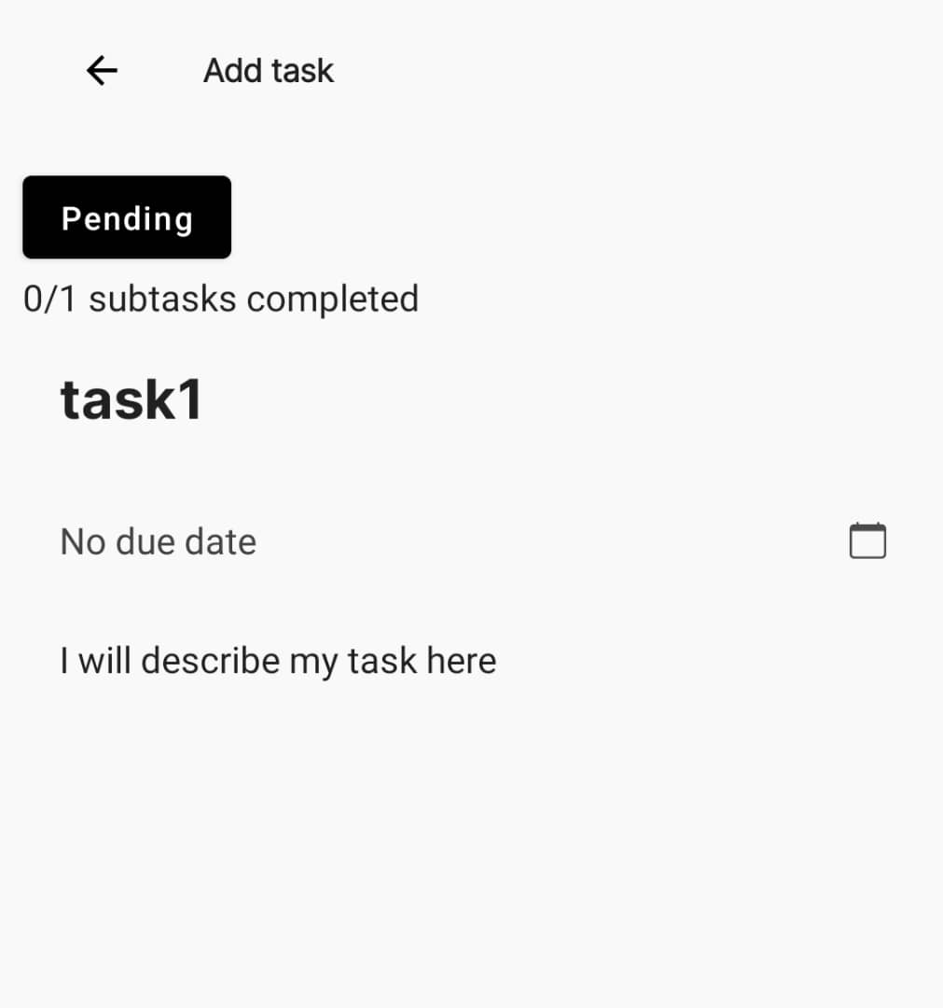

**End dates:** Users can set an end date for their tasks within the app, specifying a deadline for completion. This feature is seamlessly integrated into the task creation process, where users are prompted to input the task title, description, and the desired end date

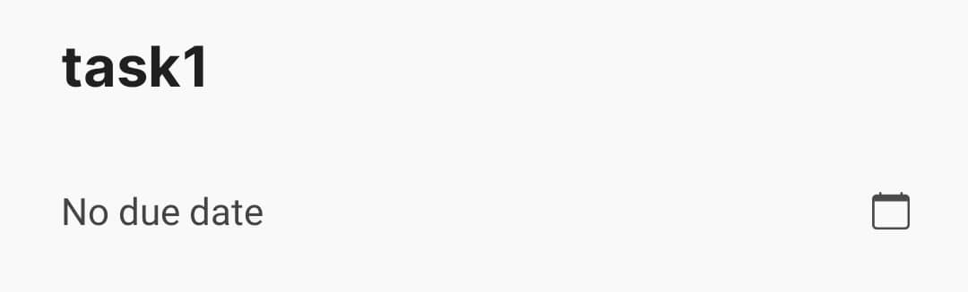

**Subtask Creation:** Users have the capability to create subtasks within the main task, facilitating a structured task hierarchy. This feature empowers users to break down larger tasks into smaller, more manageable subtasks. Users can assign titles to these subtasks, enabling clear identification and organization.

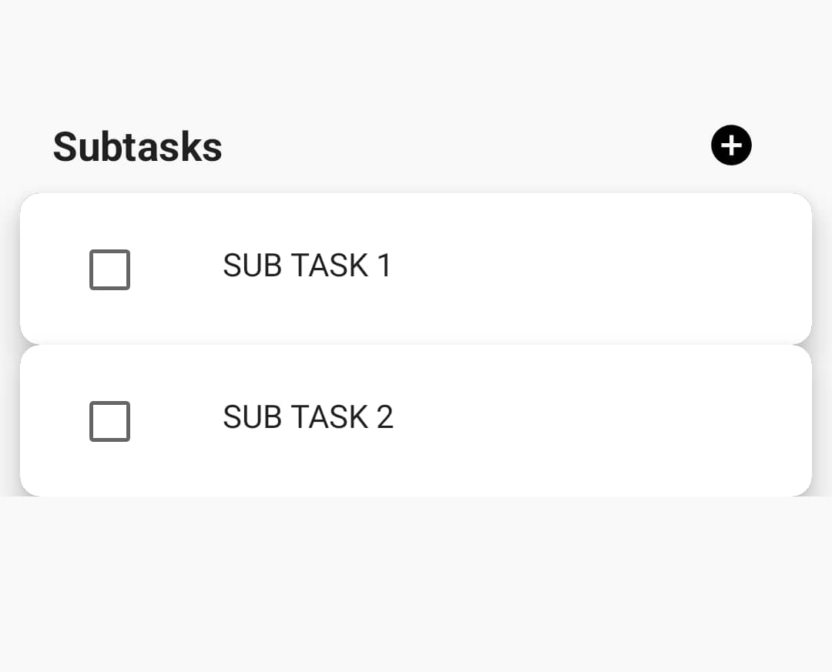

**Progress Tracking:** Once a user adds various subtasks to a main task, initially, if none of the subtasks are marked as completed, the main task status remains as "Pending." However, when the user marks at least one subtask as completed, the main task status changes to "In Progress." The app also displays a progress indicator showing the number of completed subtasks out of the total. For example, if one out of three subtasks is completed, it will show as "1/3" subtasks completed. And when all the subtask are marked as completed then the main task will also show completed and goes to done folder automatically. This dynamic update provides users with real-time feedback on their task progress, aiding them in tracking their achievements and staying motivated to efficiently complete their tasks.

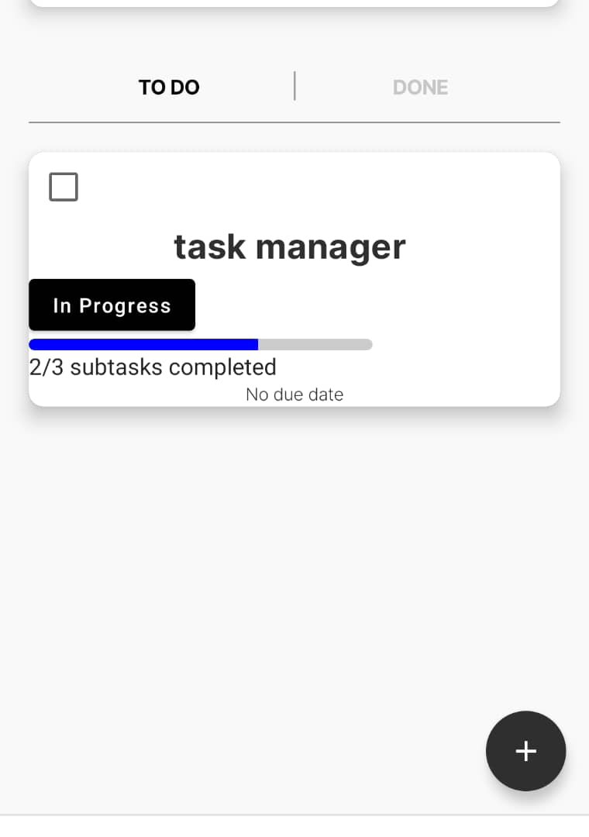

**Completion Marking:** Users have the flexibility to mark tasks as completed manually once they finish them. Alternatively, tasks can automatically mark themselves as completed when all associated subtasks are marked as completed. Upon task completion, it is moved to the "Done" folder, which showcases all completed tasks for easy reference.

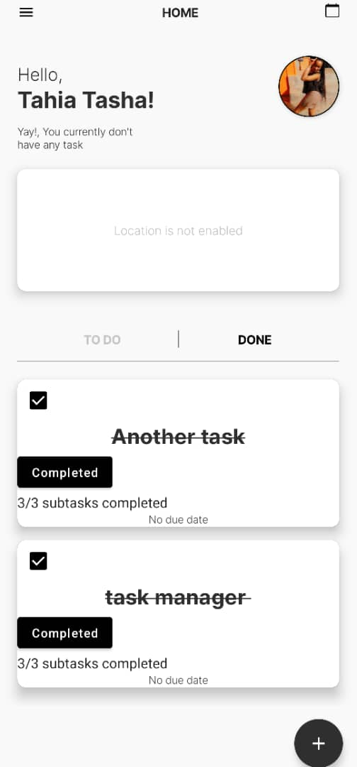

**Notifications:**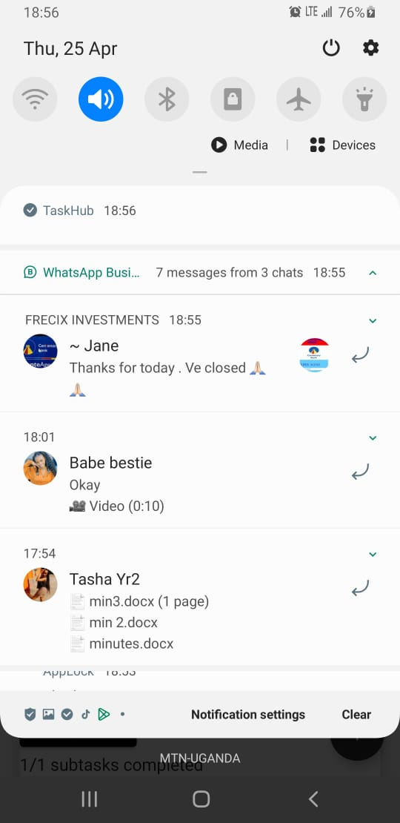 Users receive notifications on the screen when tasks are in progress and their due dates have been reached. This notification system ensures that users are promptly alerted to upcoming deadlines, enabling them to stay on top of their tasks and take necessary actions to ensure timely completion.

**Calendar:** Users can seamlessly switch between the home view and the calendar view within the app. While in the calendar view, users can select a specific date to view tasks with due dates on that date. Tasks with due dates on the selected date are visibly marked, allowing users to identify them quickly. Moreover, users can click on these marked dates to access a detailed list of tasks scheduled for those dates, facilitating efficient task management and planning.

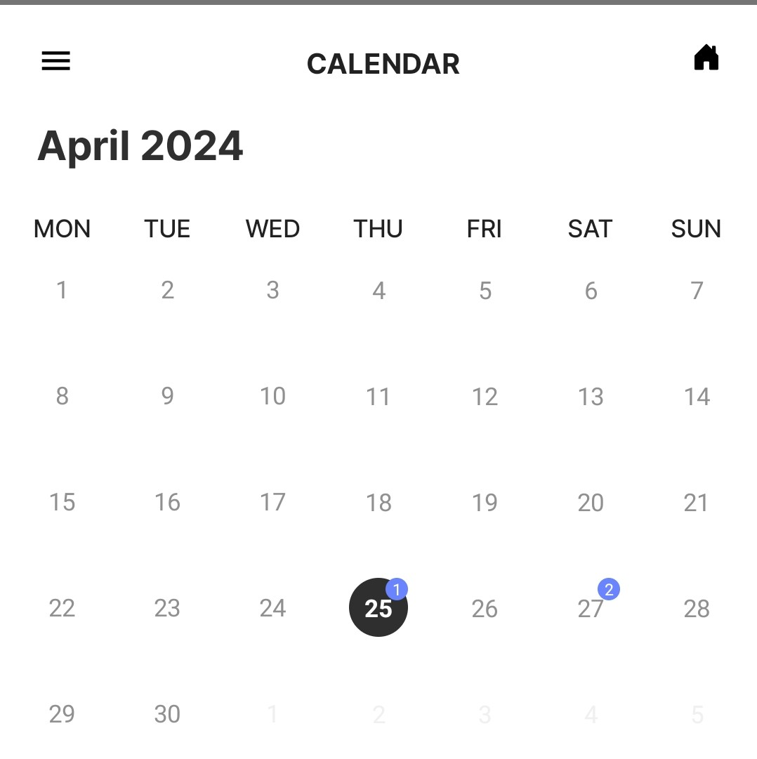

**Folders:** Two folders have been implemented in the app: the "Todo" folder and the "Done" folder. The "Todo" folder contains tasks that are either pending or in progress, while the "Done" folder houses tasks that have been completed. When a task is marked as completed either manually or automatically after all its subtasks are completed, it is moved to the "Done" folder. If the "Todo" folder becomes empty, a message is displayed notifying the user that they currently do not have any tasks to complete.

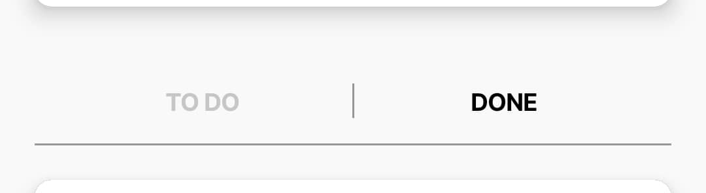

**Profile:** When a user clicks to view their profile, they can see the total number of completed tasks and the number of tasks that are pending or in progress. This feature provides users with a quick overview of their task completion progress and helps them stay informed about their remaining tasks. You can even signout of the task management app.

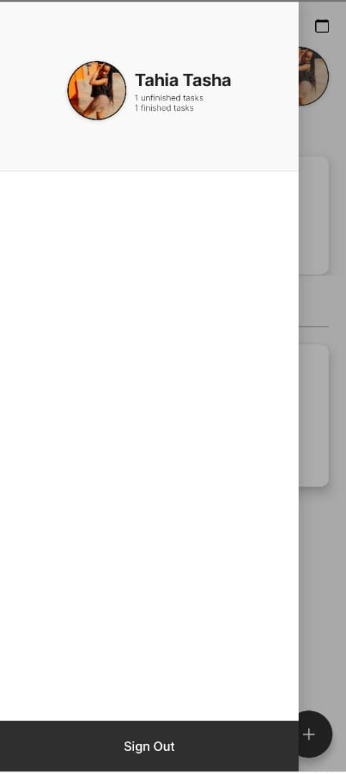

**Splash Screen:** In addition to its array of features, the Task Management App boasts a splash screen that smoothly transitions users to the sign-in page upon launching the app.

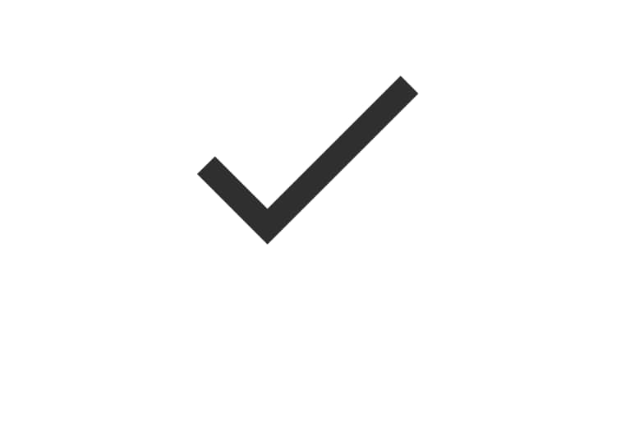

**Edit and Delete Task and Subtask:** Users can conveniently edit tasks and subtasks within the app by employing intuitive swipe gestures. To edit a task or subtask, users simply navigate to the corresponding list and swipe right on the item they wish to modify. Similarly, deletion can be swiftly executed by swiping left on the desired task or subtask within the list view. Additionally, users have the option to edit main tasks directly by tapping on the task and selecting the "Edit" button.

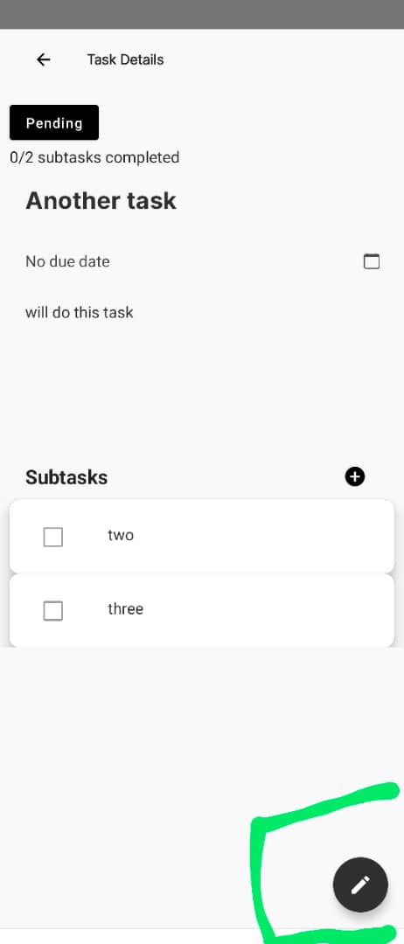

**Technical Functionality:** The app leverages Firebase for its backend services, encompassing authentication and database management, ensuring secure user authentication and efficient data handling. Employing responsive UI design, the app ensures seamless user interaction across devices, enhancing the user experience. Notification functionality is integrated for task reminders, keeping users informed and on track with their tasks. Moreover, the app employs efficient data storage and retrieval mechanisms, optimizing performance for a smooth and responsive user experience.

**CONTRIBUTION TABLE**

|  |  |
| --- | --- |
| **TEAM MEMBER** | **CONTRIBUTION** |
| NASAAZI TAKIA | Home screen (top bar , add new task float button, tasklist and categorization) |
| KAZIBWE JULIUS | Firebase configuration , the signin and signout, weather and location details , and the calendar screen |
| KISA JEREMIAH | Implemented the add/edit screen (datepicker , timepicker and the notification , subtasks ) |

**CONCLUSION**

In conclusion, the Task Management App offers a comprehensive solution for effective task management on Android devices. Leveraging Firebase for backend services ensures seamless authentication and efficient database management, providing users with a secure and reliable experience. The app's features, including login with Google, task creation with end dates and subtasks, progress tracking, completion marking, and notification reminders, empower users to stay organized and productive. The integration of a calendar view and the implementation of folders for organizing tasks further enhance usability and convenience. Additionally, the user profile feature allows users to track their task completion progress at a glance. With future enhancements planned to prioritize task management and enhance UI/UX elements, the app is poised to continue delivering an improved user experience and increased functionality